HYDRO-MAX
HM-240

HYDRAULICALLY-DRIVEN

AC GENERATOR

BY 

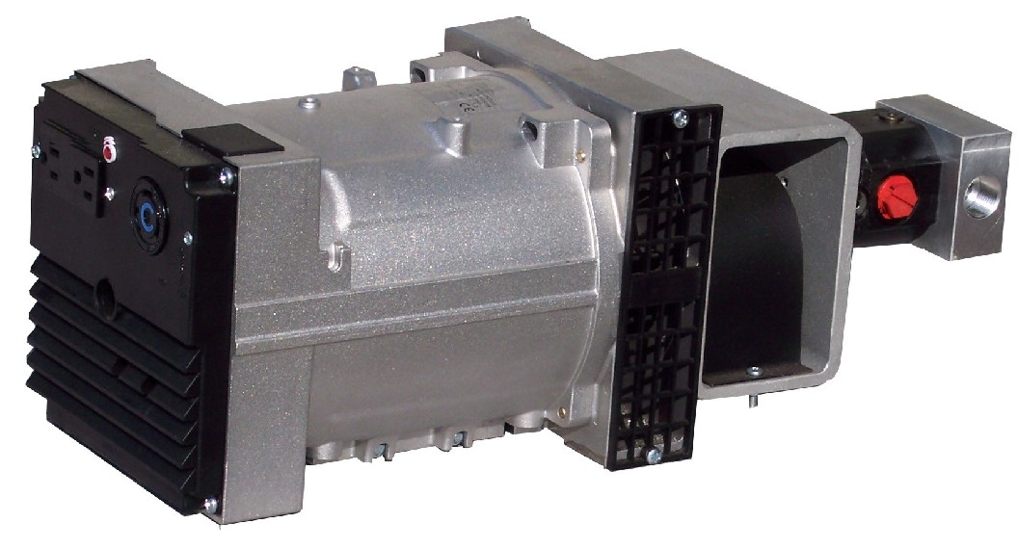

120 /
240 V
60 Hz

2400
Watts
1 Phase
\

QUALITY FEATURES
Brushless AC Generator |  | Includes Pressure Compensating Flow Regulator
Maintenance Free Design |  | Lifetime Guaranteed Alignment

SPECIFICATIONS
Flow = | 7.5 GPM |  | Volts = | 120 or 120/240
Pressure = | 1600 PSI |  | Amps = | 20 @ 120 V
Speed = | 3600 RPM |  | Watts = | 2400 Continuous
Weight = | 51 Lbs |  | Power Factor = | 1.0
Dimensions = | 7” W * 8” H * 21.5” L |  | Temperature Rating = | 105 C
FERNDALE, NY 12734
(845)-292-0800
http://www.geteck.com

